Lighthouse Community Church
Women’s Spring Event

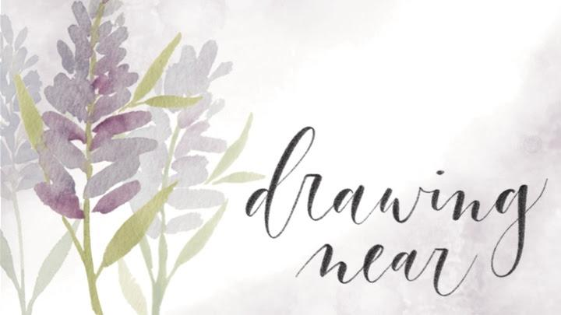

“You will seek me and find me, when you seek me with all your heart.”
Jeremiah 29:13

April 24, 2021
Speaker: Tracey Chang
Schedule

9:00 Welcome
9:10 Worship
9:20 Message Part 1
9:45 Activity 1
9:50 Message Part 2
10:10 Activity 2
10:15 Break
10:20 Message Part 3
10:35 Activity 3
10:45 Small Group Discussions
11:15 Event Ends

Part 1: Our relationship with God fuels our desire to pray

- Picture 1: Adopted and Loved (Galatians 4:4-7)

A.C.T.S: Adoration-Confession-Thanksgiving-Supplication

- Picture 2: Calmed and Quieted (Psalm 131)

Psalm 131
A Song of Ascents. Of David.
¹ O Lord, my heart is not lifted up;
my eyes are not raised too high;
I do not occupy myself with things
too great and too marvelous for me.
² But I have calmed and quieted my soul,
like a weaned child with its mother;
like a weaned child is my soul within me.

³ O Israel, hope in the Lord
from this time forth and forevermore.

~ Dependency is a mark of spiritual maturity ~

- Stirring our affections for God: Meditation

Psalm 19:14 “Let the words of my mouth and the meditation of my heart
be acceptable in your sight, O Lord, my rock and my redeemer.

Philippians 4:8 “Finally, brothers, whatever is true, whatever is honorable, whatever is just, whatever is pure, whatever is lovely, whatever is commendable, if there is any excellence, if there is anything worthy of praise, think about these things.”

Ephesians 5:18b-19 “Be filled with the Spirit...singing and making melody to the Lord with your heart.”

Activity 1: Meditating on Psalm 84 (5 minutes, on your own)
1. Read through it once 2. Pick a stanza 3. Delight in the Lord!

Psalm 84
To the choirmaster: according to The Gittith. A Psalm of the Sons of Korah.
¹ How lovely is your dwelling place,
O Lord of hosts!
² My soul longs, yes, faints
for the courts of the Lord;
my heart and flesh sing for joy
to the living God.

³ Even the sparrow finds a home,
and the swallow a nest for herself,
where she may lay her young,
at your altars, O Lord of hosts,
my King and my God.
⁴ Blessed are those who dwell in your house,
ever singing your praise! Selah

⁵ Blessed are those whose strength is in you,
in whose heart are the highways to Zion.
⁶ As they go through the Valley of Baca
they make it a place of springs;
the early rain also covers it with pools.
⁷ They go from strength to strength;
each one appears before God in Zion.

⁸ O Lord God of hosts, hear my prayer;
give ear, O God of Jacob! Selah
⁹ Behold our shield, O God;
look on the face of your anointed!

¹⁰ For a day in your courts is better
than a thousand elsewhere.
I would rather be a doorkeeper in the house of my God
than dwell in the tents of wickedness.
¹¹ For the Lord God is a sun and shield;
the Lord bestows favor and honor.
No good thing does he withhold
from those who walk uprightly.
¹² O Lord of hosts,
blessed is the one who trusts in you!
Part 2: Words to pray by

- Why praying is hard

- Psalms in the time of quarantine

Dietrich Bonhoeffer: “The richness of the Word of God ought to determine our prayer, not the poverty of our heart. It does not depend, therefore, on whether the Psalms express adequately that which we feel at a given moment in our heart. If we are to pray aright, perhaps it is quite necessary that we pray contrary to our own heart.”

- Two ways to pray Scripture

- Pray the exact words as your own
- addressing God
- addressing your own soul

- Pray Scripture like a conversation

- Adoration is simply telling God who He is

2 Corinthians 3:18a “And we all, with unveiled face, beholding the glory of the Lord, are being transformed into the same image from one degree of glory to another.”

Activity 2: Praying adoration with Psalm 23 (5 minutes, in groups)

Psalm 23
A Psalm of David
¹ The Lord is my shepherd; I shall not want.
² He makes me lie down in green pastures.
He leads me beside still waters.
³ He restores my soul.
He leads me in paths of righteousness
for his name's sake.

⁴ Even though I walk through the valley of the shadow of death,
I will fear no evil,
for you are with me;
your rod and your staff,
they comfort me.

⁵ You prepare a table before me
in the presence of my enemies;
you anoint my head with oil;
my cup overflows.
⁶ Surely goodness and mercy shall follow me
all the days of my life,
and I shall dwell in the house of the Lord
forever.

Part 3: Asking God to be God

- Takeaway cards
(examples at back)

Helpful book on lament:
Dark Clouds, Deep Mercy
by Mark Vroegop

- Asking God to be God

Numbers 14:17-19 “…please let the power of the Lord be great as you have promised, saying, ‘The Lord is slow to anger and abounding in steadfast love, forgiving iniquity and transgression, but he will by no means clear the guilty….’ Please pardon the iniquity of this people, according to the greatness of your steadfast love, just as you have forgiven this people, from Egypt until now.”

- Anywhere, all the time

1 Thessalonians 5:16-18 “Rejoice always, pray without ceasing, give thanks in all circumstances; for this is the will of God in Christ Jesus for you.”

Activity 3: Responding to Jeremiah 29:10-14 (5 minutes, on your own)

Jeremiah 29:10-14 ¹⁰ For thus says the Lord: When seventy years are completed for Babylon, I will visit you, and I will fulfill to you my promise and bring you back to this place. ¹¹ For I know the plans I have for you, declares the Lord, plans for welfare and not for evil, to give you a future and a hope. ¹² Then you will call upon me and come and pray to me, and I will hear you. ¹³ You will seek me and find me, when you seek me with all your heart. ¹⁴ I will be found by you, declares the Lord, and I will restore your fortunes and gather you from all the nations and all the places where I have driven you, declares the Lord, and I will bring you back to the place from which I sent you into exile.

Small Group Discussion Questions

- How can knowing God as your Abba Father and you as His daughter change or affect your prayer life? (Think of the adoption illustration Tracey gave.)
- (a) Think about some of the closest relationships in your life. Share what you enjoy most about those relationships. (b) Tracey shared that our relationship with God is the basis for our prayers. What are some ways you can cultivate your relationship with God to enjoy Him and know Him more intimately?
- Tracey shared some practical ways we can use the box of takeaway cards. Do you have verses or truths that have shaped your prayers in which you could share? What are other practical ways to use takeaway cards to grow your prayer life?

Takeaway card examples
(Feel free to do them however you like!)
